INCIDENT & SAFETY REPORT
Date of occurence: August 13, 2026
Author: Trần Đức Anh
Location: Open Lab 24/7
Project/Task: Motion Control / Stepper Motor Bench Testing
Direct Supervisor: Professor Simon Park
Research Assistant: Luong Hong Duong
1. Incident Summary
On August 13, 2026, at approximately between 12 and 12:30 am, during a bench setup and wiring test requested by Research Assistant Luong Hong Duong, a short circuit occurred across the 220V AC input line. While attempting to check the DC voltage output of the power setup, a probe misconfiguration caused an immediate high-current short that cut all power the the Open Lab.
- Root Cause Analysis
2.1 Root Cause
The primary cause of the incident was an incorrect multimeter probe configuration and incorrect terminal identification during a live voltage measurement.
2.2 Detail description of failure:
The purpose of the measurement was to verify the DC output voltage of the Mean Well 48 V power supply ( Image 3). The intended measurement points were the V+ and V− DC output terminals.
The multimeter was configured for DC voltage measurement ( Image 1). However, due to an incorrect positioning of the probes and insufficient verification of the measurement points, the probes were inadvertently placed across the L (Live) and N (Neutral) terminals on the AC input side of the RCBO/power supply.( Image 2)
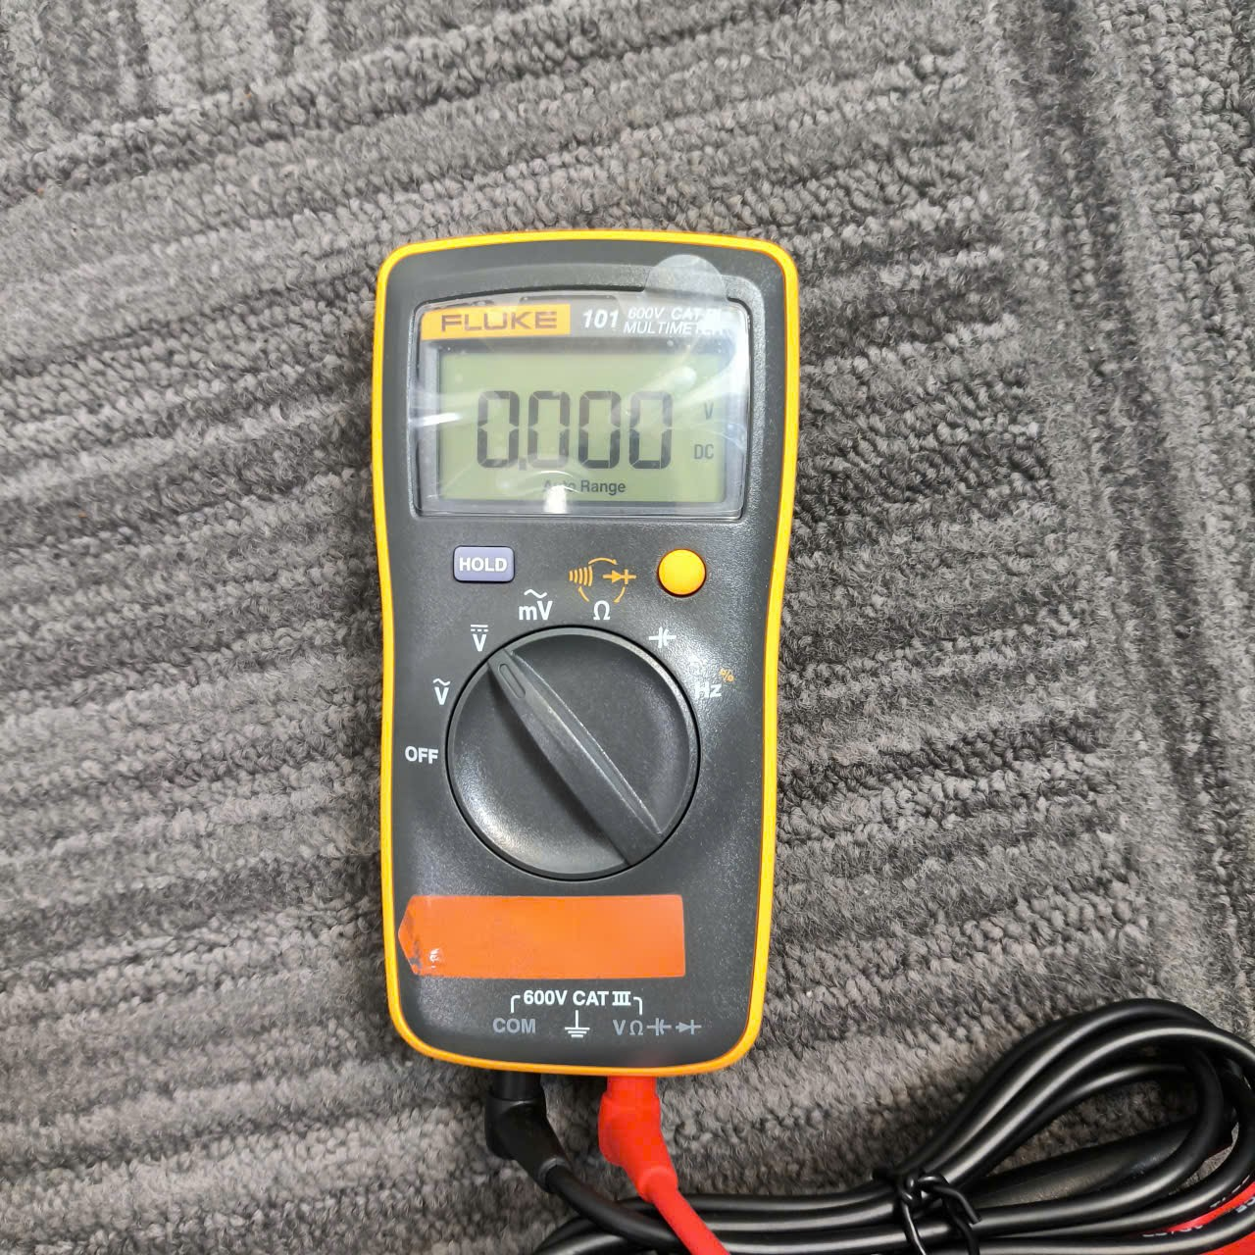
Image 1: Configuration of measure of Multimeter at the incident
When the probes contacted the Live and Neutral terminals simultaneously, the multimeter and its leads provided a low-impedance path between the two AC conductors. This resulted in a high-current fault condition and caused the laboratory power supply protection system to operate, interrupting power to the Open Lab.
The incident demonstrates the importance of verifying both the multimeter configuration and the physical measurement points before making any measurement on an energized circuit.
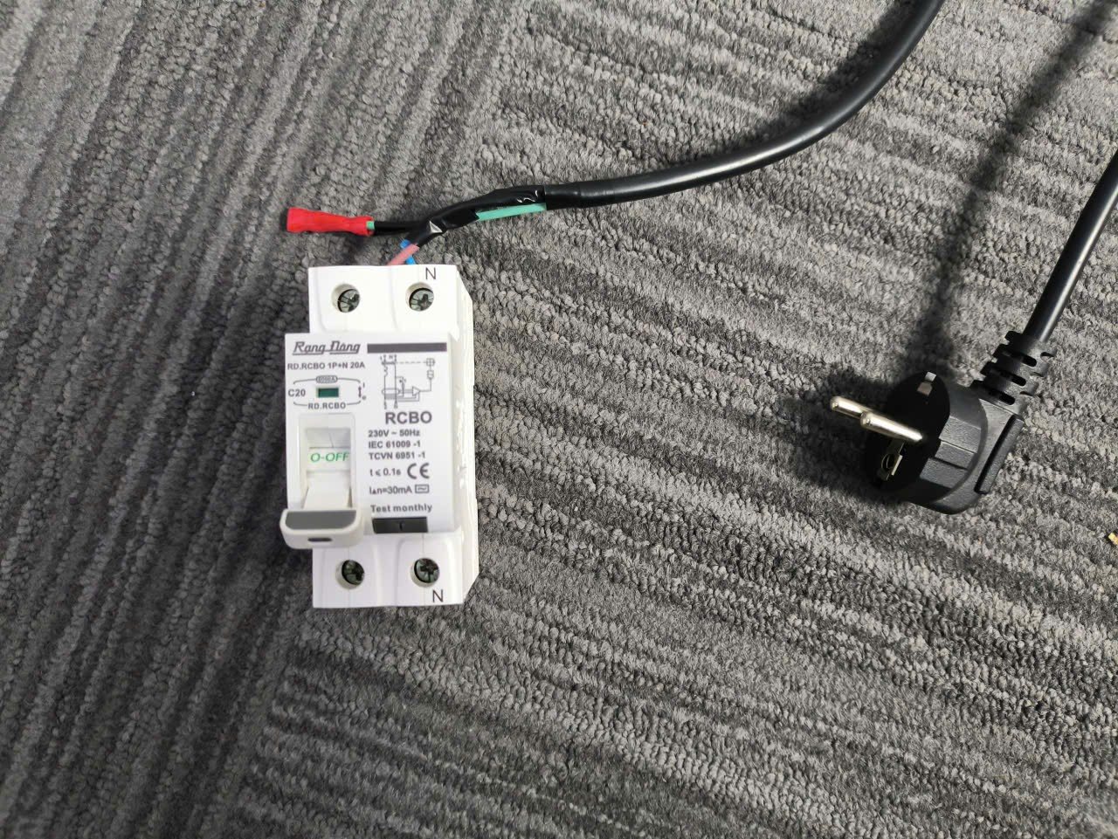
Image 2: Power Source and RCBO
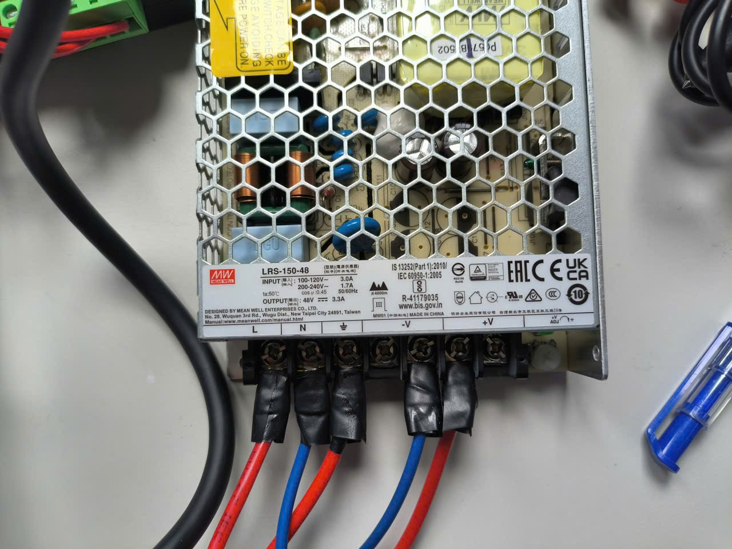
Image 3: Meanwell DC Power supply - 48V
2.3 Contributing factors
The following factors contributed to the incident:
- The measurement points were not physically traced and positively identified immediately before probe contact.
- Lack of approved testing plan prior to the test being carried out
- Lack of safety training and knowledge in operating electrical test equipments
3. Equipment and Facility Damage Assessment
Multimeter Probes: The alligator clip on the red probe sustained minor arcing, resulting in a slightly blackened tip.
Multimeter Unit: The display logic powers on normally, but the internal condition of the current measurement circuit remains uncertain until the internal ceramic fuse is inspected and tested for continuity.
Bench Components: No visible damage was identified on the bench equipment. Further testing will be needed for confirmation of internal damage
Facility & Equipment: No visible damage to the laboratory infrastructure or other equipment was identified.
Laboratory power was successfully restored, and the Open Lab is currently operating normally.
- Corrective Action and Preventive Action
  - Corrective Actions
- Affected equipments and facility were inspected for visible signs of damage, orheating, arcing, or abnormal operation.
- Incident have been communicated to direct supervisor and relevant RÁ for the event to be reviewed and similar incident can be prevented
- Reviewed the electrical schematic and physical wiring of the bench along with relevant RÁ before any further enegized testing
  - Preventive Actions
To reduce the likelyhood of recurrence of such incident, the follow procedures will be carried out and implemented by MEDAL Lab for future test/work:
- Communicate this incident to all related personel of MEDAL, including PI, Post Docs, RAs and students. This incident will act as an example for any work related
- Implementation of a safety management procedure and training for all MEDAL personel. The architecture of the safety management will be as follow:
ID | Safety plan | Applies to
LSP-00 | Master Laboratory Safety Plan | Everyone entering/working in the lab
ESP-01 | Electrical Safety Plan | Circuits, power electronics, sensors, batteries, electrical test systems
MSP-01 | Mechanical & Fabrication Safety Plan | CNC, lathe, mill, drill, cutting, grinding, welding, robots
CSP-01 | Chemical Safety / Chemical Hygiene Plan | Chemicals, gases, solvents, electrochemistry, coatings
MAT-01 | Materials Processing Safety Plan | Powders, nanoparticles, composites, furnaces, 3D printing, resins
ERP-01 | Emergency & Incident Response Plan | Fire, spill, electrical incident, injury, gas release, evacuation
The details of each safety plan will be approved by Prof. Simon Park and related training will be done weekly for all personel.
- Implementation of risk classfication before carrying out any test
Level | Example | Requirement
R1 – Low | Computer work, low-energy sensors, simple assembly | General lab training
R2 – Moderate | Soldering, benchtop chemicals, 3D printers, machine tools | Specific training + SOP
R3 – High | Energized exposed circuits, high-energy batteries, welding, pressure systems, reactive/toxic gases, hazardous chemistry | Written risk assessment + authorized user + supervisor approval
- Reference Safety Materials
- General Laboratory safety training:
https://www.youtube.com/watch?v=TlhVR0xQLJQ
- Chemical Safety training:
https://www.youtube.com/watch?v=ALBWxGik64A
https://www.youtube.com/watch?v=DWSymRPCDN4
- Viet Nam’s chemical safety training of group 3:
https://viendaotao.vn/wp-content/uploads/2026/04/T%C3%A0i-li%E1%BB%87u-hu%E1%BA%A5n-luy%E1%BB%87n-an-to%C3%A0n-h%C3%B3a-ch%E1%BA%A5t.pdf
- Electrical Safety training
https://www.youtube.com/watch?v=ggJo6m8NZtA
- Viet Nam’s electrical safety training of group 3
https://viendaotao.vn/wp-content/uploads/2026/04/T%C3%A0i-li%E1%BB%87u-hu%E1%BA%A5n-luy%E1%BB%87n-an-to%C3%A0n-%C4%91i%E1%BB%87n-Nh%C3%B3m-3.pdf
- Guide for using a multimeter:
https://www.youtube.com/watch?v=0loXukB302Q
- Mechanical Safety training
https://www.youtube.com/watch?v=PP9dYoN8pTk

